Sight Words
big, like, get mother, come, went,
into, play

Grade 1 News

Upcoming events
December 14th – Holiday Concert
December 15th – Shopping Party
December 22nd – PJ & Movie Day
December 23rd –Last Day of school before the Holidays (dismissal @ 12:05)
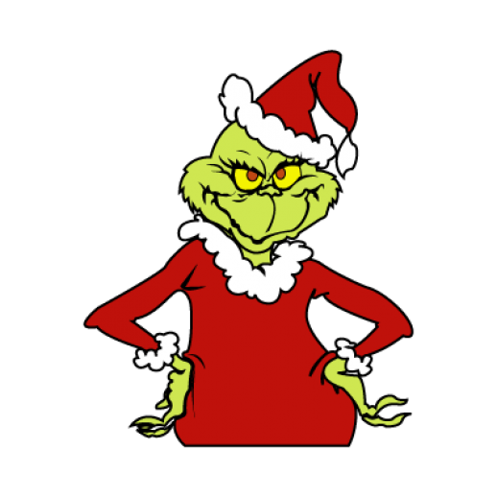

Notes from the teacher:
With the cold weather upon us please ensure that your child has mittens/gloves and a hat.
Annual Holiday Concert is planned for December 14th – storm date is December 21st.(Show times 9:00 & 11:00)
On December 22, students are allowed to wear their PJ’s and bring a stuffy (must fit in their backpacks). We will be watching a movie on this day as well.
December 23 (last day before break) is a ½ day dismissal will be at 12:05.


What we are learning this week:

Reading | Writing | Math | You and Your World
- Word family -ue  - Strategy – Flippy Dolphin  - Letters – ue  - Daily 5  - Rules – “When Two Vowels go walking”&  - “magic e”, bossy R | - Trait – ORGANIZATION  Trait – Conventions  “Did I use the right punctuation?”  - Writer’s Workshop  - “How to” writing – How to build a snowman, etc… | - Continue with Numbers to 30  - Skip counting by 2’s& 5’s  - Counting backwards  - Counting from a given number  - Estimating  - Emphasis equal and balanced. | - We will be doing a cross curricular theme based on “The Grinch” focusing on the importance of kindness and empathy.

Please contact me if you have any questions or concerns – rolly.sidik@nbed.nb.ca.

